* 9 minutes

Azure is a continually expanding set of cloud services that help your organization meet your current and future business challenges. Azure gives you the freedom to build, manage, and deploy applications on a massive global network using your favorite tools and frameworks.

## What does Azure offer?

With help from Azure, you have everything you need to build your next great solution. The following table lists several of the benefits that Azure provides, so you can easily invent with purpose.

**Be ready for the future:** Continuous innovation from Microsoft supports your development today and your product visions for tomorrow.



Image that shows a launching rocket ship to represent the future.



Image that shows three slider bars to represent choice in your usage needs.

**Build on your terms:** You have choices. With a commitment to open source, and support for all languages and frameworks, you can build how you want and deploy where you want to.

**Operate hybrid seamlessly:** On-premises, in the cloud, and at the edge–we’ll meet you where you are. Integrate and manage your environments with tools and services designed for a hybrid cloud solution.



Image that shows a brick building datacenter next to a cloud datacenter to represent both datacenters working together.



Image that shows a shield over a cloud to represent cloud security.

**Trust your cloud:** Get security from the ground up, backed by a team of experts, and proactive compliance trusted by enterprises, governments, and startups.

## What can I do with Azure?

Azure provides more than 100 services that enable you to do everything from running your existing applications on virtual machines, to exploring new software paradigms, such as intelligent bots and mixed reality.

Many teams start exploring the cloud by moving their existing applications to virtual machines that run in Azure. Migrating your existing apps to virtual machines is a good start, but the cloud is much more than a different place to run your virtual machines.

For example, Azure provides AI and machine-learning services that can naturally communicate with your users through vision, hearing, and speech. It also provides storage solutions that dynamically grow to accommodate massive amounts of data. Azure services enable solutions that aren’t feasible without the power of the cloud.

## How does Azure work?

## What is the Azure portal?

The Azure portal is a web-based, unified console that provides an alternative to command-line tools. With the Azure portal, you can manage your Azure subscription by using a graphical user interface. You can:

* Build, manage, and monitor everything from simple web apps to complex cloud deployments.
* Create custom dashboards for an organized view of resources.
* Configure accessibility options for an optimal experience.

The Azure portal is designed for resiliency and continuous availability. It maintains a presence in every Azure datacenter. This configuration makes the Azure portal resilient to individual datacenter failures and avoids network slowdowns by being close to users. The Azure portal updates continuously and requires no downtime for maintenance activities.

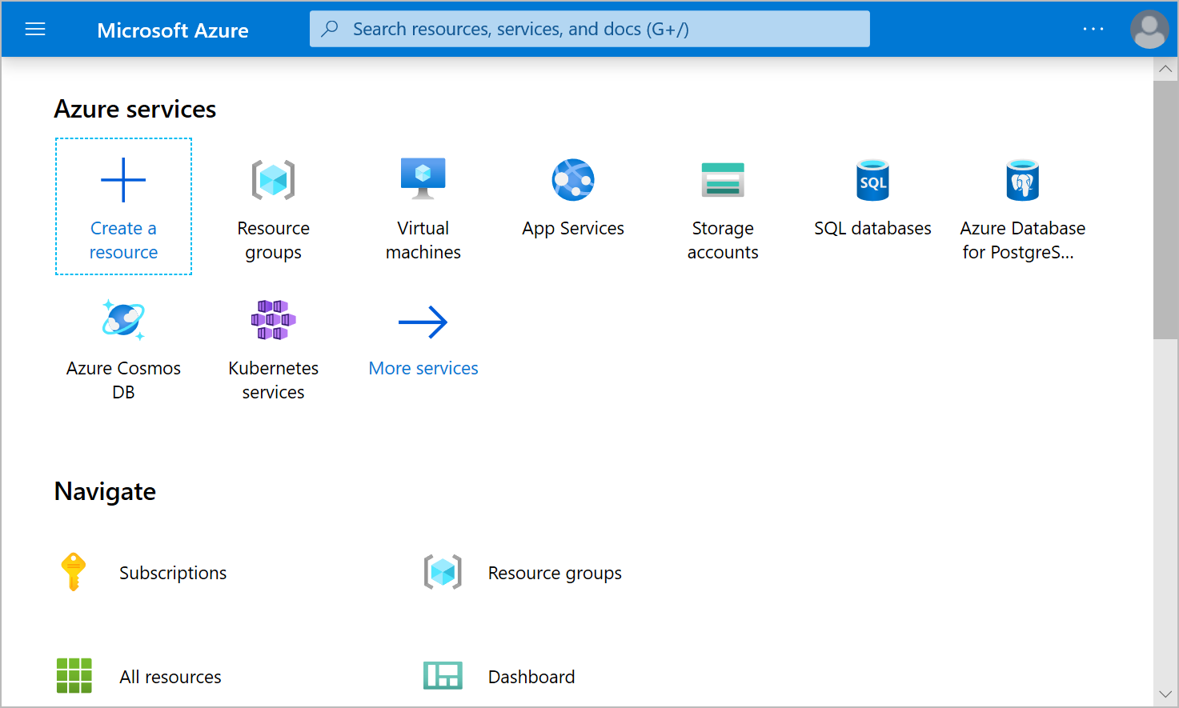

Screenshot that shows the Azure portal.

## What is Azure Marketplace?

[Azure Marketplace](https://azuremarketplace.microsoft.com/) helps connect users with Microsoft partners, independent software vendors, and startups that are offering their solutions and services, which are optimized to run on Azure. Azure Marketplace customers can find, try, purchase, and provision applications and services from hundreds of leading service providers. All solutions and services are certified to run on Azure.

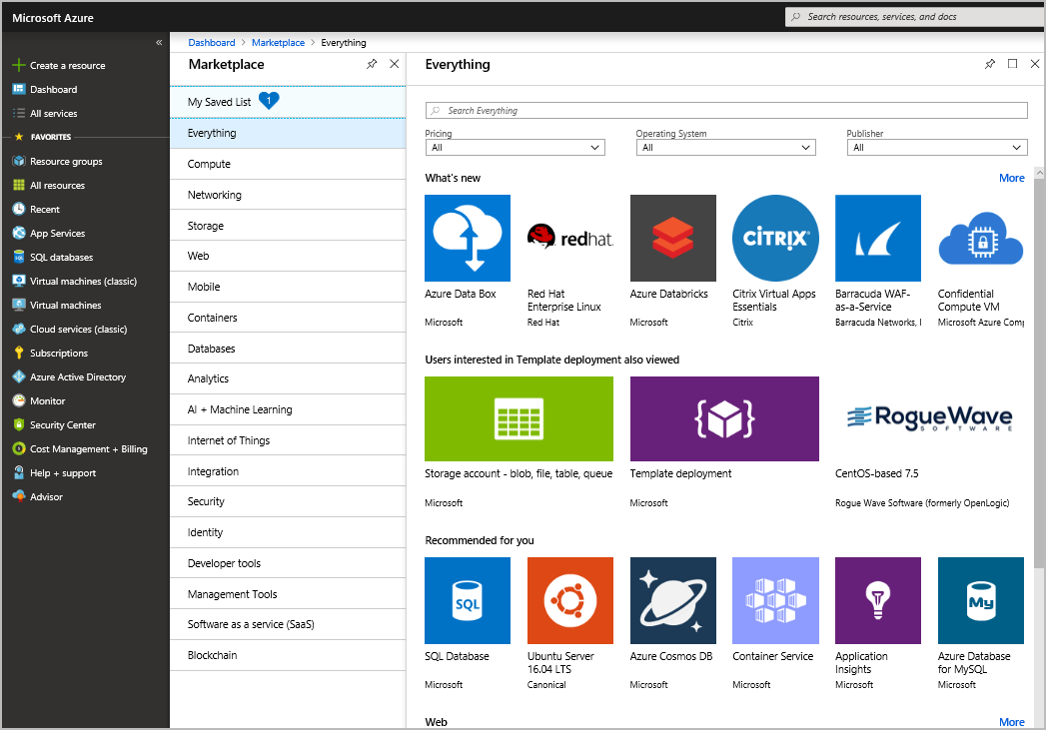

Screenshot that shows Azure Marketplace.

The solution catalog spans several industry categories such as open-source container platforms, virtual machine images, databases, application build and deployment software, developer tools, threat detection, and blockchain. Using Azure Marketplace, you can provision end-to-end solutions quickly and reliably, hosted in your own Azure environment. At the time of writing, there are more than 8,000 listings.

Azure Marketplace is designed for IT pros and cloud developers interested in commercial and IT software. Microsoft partners also use it as a launch point for all joint go-to-market activities.

## Next unit: Tour of Azure services

[Continue](https://docs.microsoft.com/en-us/learn/modules/intro-to-azure-fundamentals/tour-of-azure-services/)